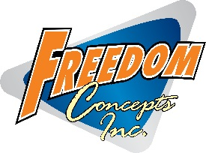
FREEDOM CONCEPTS INC. HIRES A NEW CENTRAL TERRITORY MANAGER

FOR IMMEDIATE RELEASE:

WINNIPEG, CANADA, August 22, 2018 – Freedom Concepts Inc., is the leading innovator in the custom adaptive tricycle industry and alternative seating. Freedom Concepts is happy to announce that Evan Paterson will be the new Central Territory Manager. Evan will be covering Wisconsin, Minnesota, Kansas, Michigan, Iowa, Missouri and Saskatchewan.
Evan has grown with the company for over 5 years managing the Marketing Department and is excited to bring his passion and dedication to this new role. Over the five years, Evan has worked with many families, dealers, non-profits and funding organizations. Evan is determined to assist customers with any questions they may have regarding Freedom Concepts adaptive bikes or Chill-Out Chairs.
Freedom Concepts Inc. continues to innovate new products while expanding around its mission of Creating a Cycle of Mobility – The cycle of mobility — it’s more than a tagline. It’s the idea that every one of us at Freedom Concepts is dedicated to. Creating handcrafted products with pride, quality, and ingenuity, with the goal of providing therapy, recreation, fun, and most of all, freedom. Adding Evan Paterson to the Freedom Concepts team will strengthen the Cycle of Mobility within the territories he’s working and expand Freedom Concept’s knowledge and expertise on adaptive bikes and Chill-Out Chairs.
Evan Paterson can be reached at 204-801-5172 or evan@freedomconcepts.com
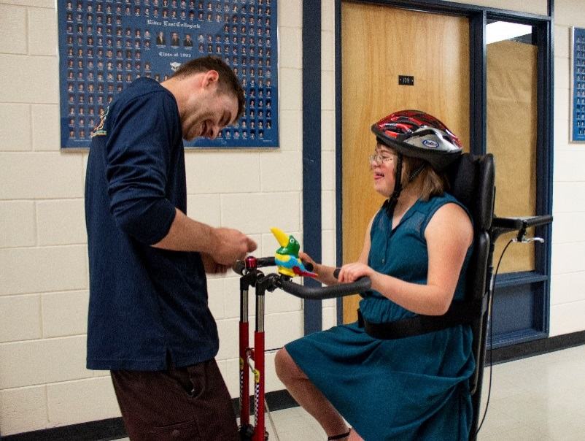
Freedom Concepts Inc. has been imagining, designing, and building a full line of adaptive bicycles, alternative seating, and mobility devices for over twenty-five years. www.freedomconcepts.com
-30-
For additional information please contact:
Harley Hudon
Marketing Coordinator
Freedom Concepts Inc.
harley@freedomconcepts.com
1 (800) 661-9915 ext. 205

Freedom Concepts Inc. – 2087 Plessis Road – Winnipeg, Manitoba, Canada R3W 1S4 – 1.800.661.9915 - www.freedomconcepts.com

